I have selected **American_time_use.xlsx** dataset from the sample data found in the source file. I have considered to visualize the data present in the considered dataset by using line graph, Bubble chart, Pie chart.

**LINE GRAPH:** This line graph is one way to visually represent quantities that change over time. A line graph represents the change in one or more quantities over time. In line graphs, data points are plotted and then connected by line segments to show the value of quantity of several different times.

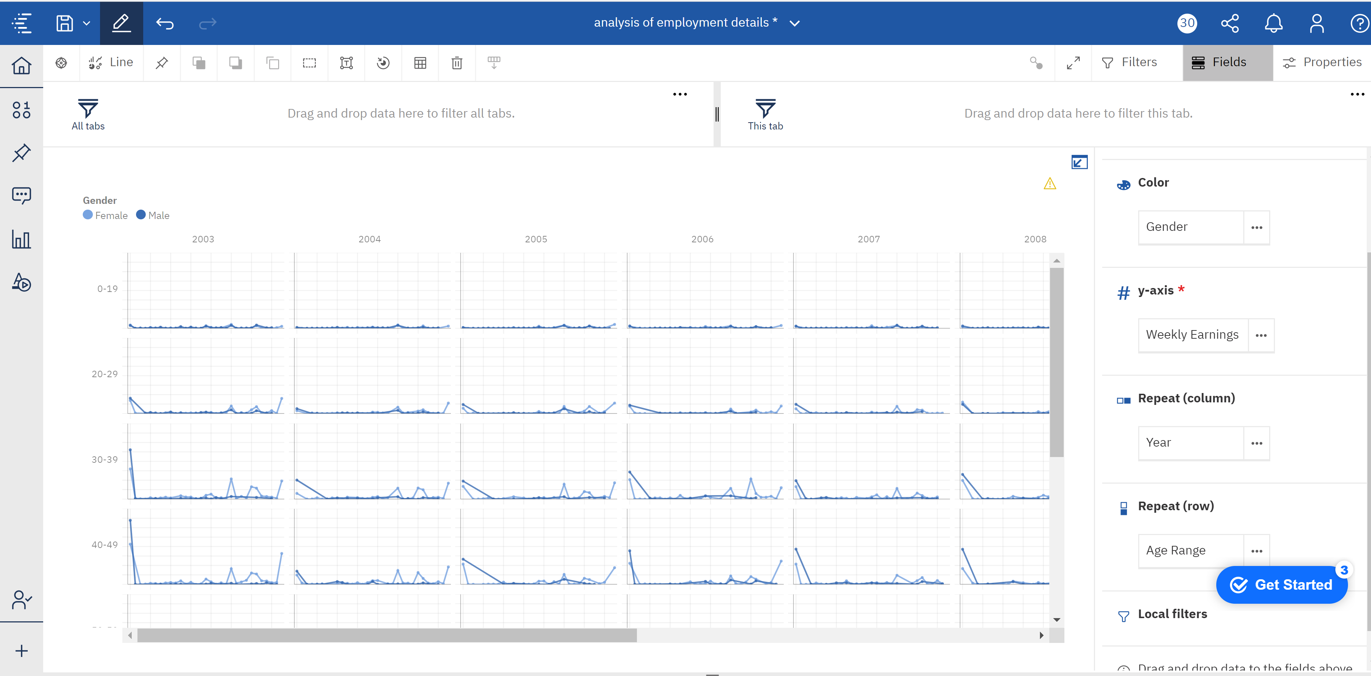

By considering weekly hours worked in x-axis, color in gender, y-axis weekly earnings, repeat column which is separated by year, and repeat row which is separated by age range. Which gives the earnings of age range and color difference differentiate the gender. My story to tells the weekly earnings based on the hourly work for different age groups and it also varies under difference in gender and the visualization change for every year from 2003 to 2012. By look at the above visualizations I think the line graphs has defined the path and intersections of the curves of the male and female.

**BUBBLE CHART:** A bubble chart is a type of chart that displays three dimensions of data. Each bubble expresses three types of data values, which are in x-axis, y axis and based on size as well.

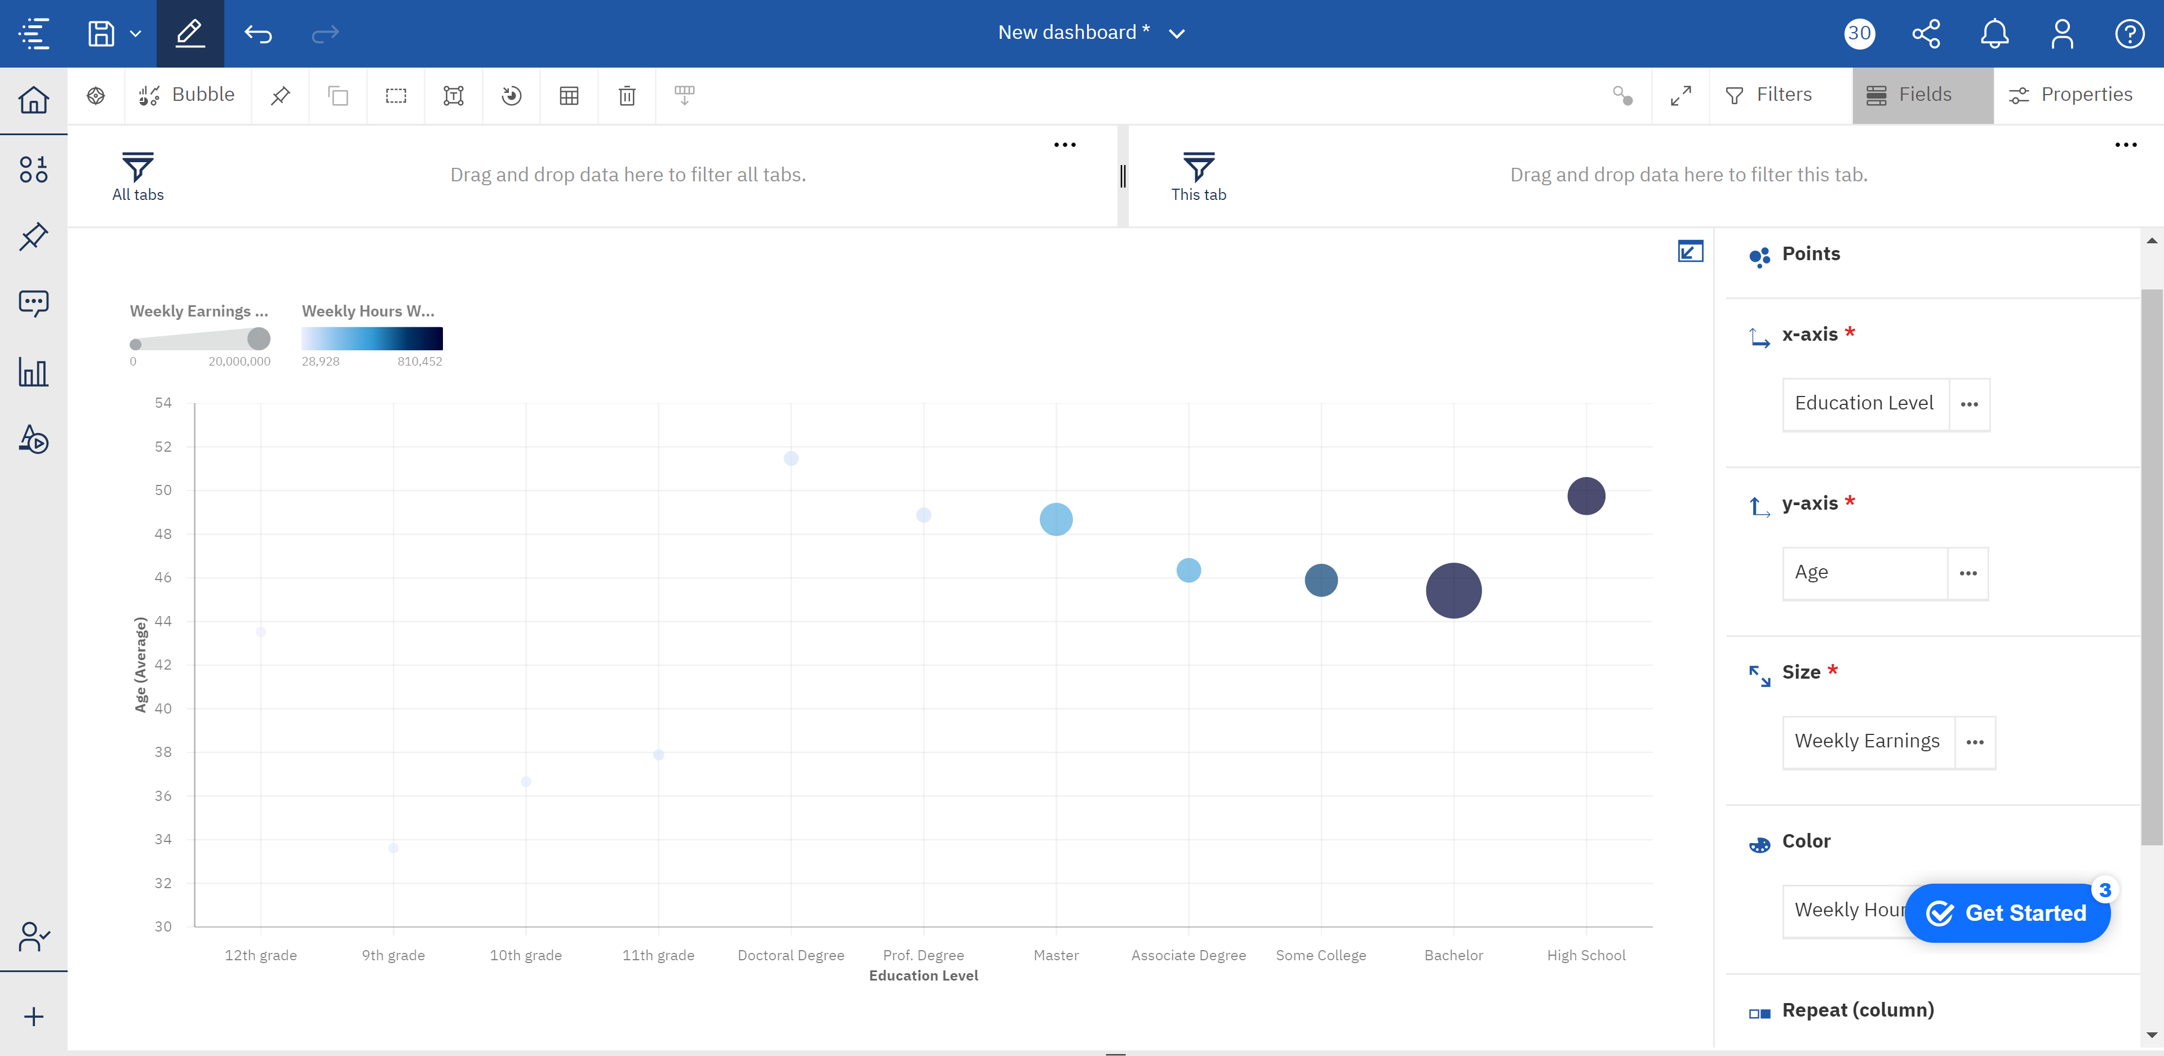

I have considered age over education level with there weekly earning based on weekly hours worked. So, this story tell about the population with bachelor are working more and earning more as well. Next comes high school, next some college degree and so on based on the color intensity.

**PIE CHART:** This Pie Chart shows the proportional data by each category that is provided and that slice of pie show the corresponding data of that proportion.

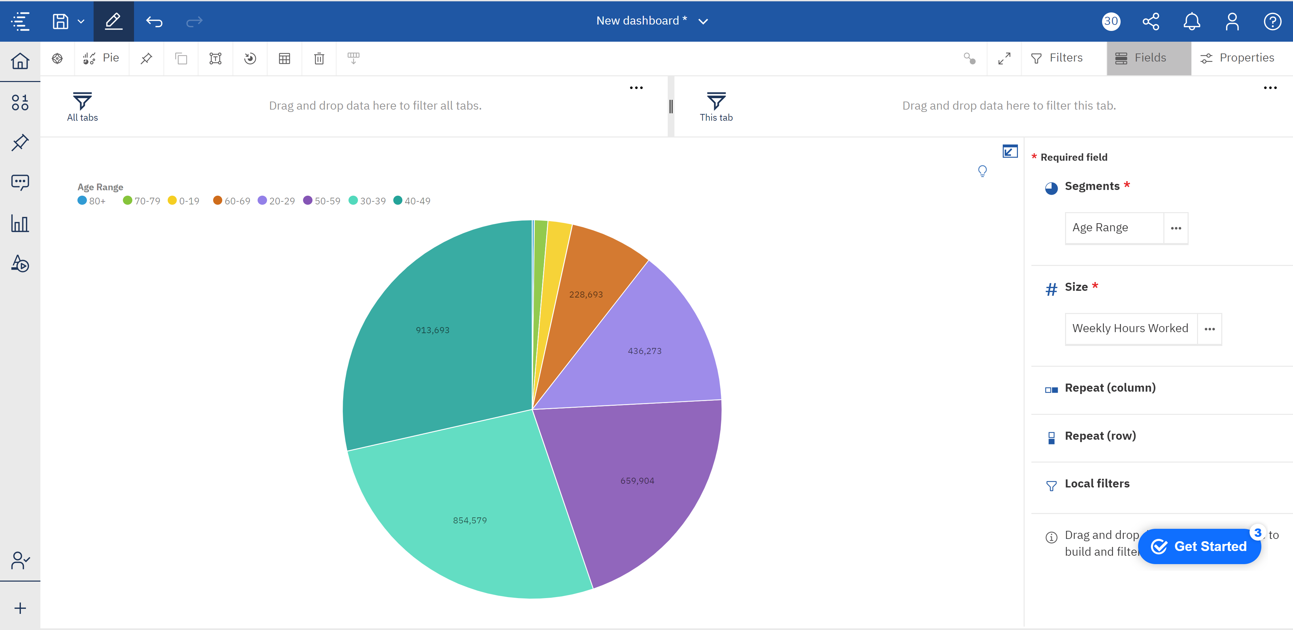

By using the age range and Weekly hours worked I have constructed this Pie Chart. This tells the story of the what age range is working hard for many hours for living. So, by this representation I have noted that 40-49 age range population is working the fullest, next follows the 30-39 age range population, next 50-59, later 20-29, then comes the 60-69 age range population and then kids, finally the senior citizens.

These are the three visualization I have figured using the American_time_use.xlsx dataset.

**References:**

1. <https://www.google.com/search?q=what+does+pie+chart+mean&oq=what+does+pie+chart+&aqs=chrome.1.69i57j0l7.7257j1j7&sourceid=chrome&ie=UTF-8>
2. <https://study.com/academy/lesson/what-is-an-area-chart-definition-examples.html>
3. <https://www.google.com/search?q=what+does+bubble+graph+mean&oq=what+is+bubble+graph&aqs=chrome.3.69i57j0l4.12615j0j7&sourceid=chrome&ie=UTF-8>